PROGRAM-6
1. Problem Statement
Repeated words and phrases can occur multiple times in a paragraph. Identifying them helps in text analysis and understanding word usage. In this case study, a Python program is developed to accept a paragraph, convert the text to lowercase, count the occurrences of each word, identify repeated words, and display their positions in the paragraph using string and list operations.
2. Objectives
- To accept a paragraph from the user.
- To convert the paragraph into lowercase.
- To separate the paragraph into individual words.
- To count the occurrences of each word.
- To identify repeated words in the paragraph.
- To display the positions of repeated words.
3. Assumptions
- The paragraph is entered by the user.
- Uppercase and lowercase versions of a word are treated as the same word.
- Basic punctuation marks are removed before counting words.
- Word positions are numbered starting from 1.
- A word is considered repeated if it appears more than once.
- The program uses basic Python string operations, lists, loops, and conditional statements.
4. Algorithm
- Start.
- Read a paragraph from the user.
- Convert the paragraph into lowercase.
- Split the paragraph into words.
- Remove basic punctuation marks from the words.
- Create lists to store unique words, their counts, and their positions.
- Traverse each word and record its position.
- If the word already exists, increase its count and record the new position.
- Otherwise, add the word to the lists with a count of 1.
- Display the words that occur more than once and their positions.
- Stop.
5. Flowchart
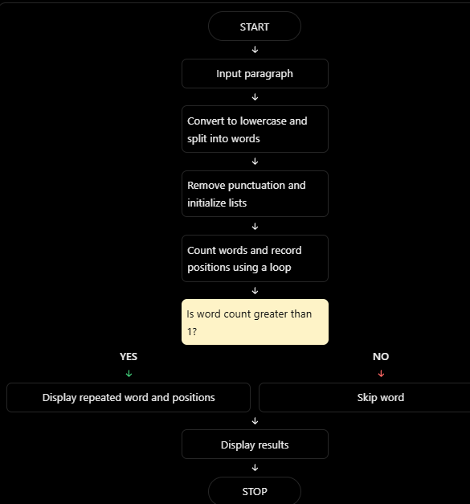
6.Pseudocode
START

INPUT paragraph
CONVERT paragraph to lowercase
SPLIT paragraph into words

CREATE empty lists:
unique_words
counts
positions

FOR each word at position i:
REMOVE punctuation from word

IF word is not empty:
IF word exists in unique_words:
INCREASE its count
ADD position i + 1 to its positions
ELSE:
ADD word to unique_words
SET count to 1
STORE position i + 1

DISPLAY "Repeated Words"

FOR each word in unique_words:
IF count is greater than 1:
DISPLAY word
DISPLAY count
DISPLAY positions

IF no repeated words are found:
DISPLAY "No repeated words found"

STOP

7.Python Source Code

paragraph = input("Enter a paragraph: ")

paragraph = paragraph.lower()
words = paragraph.split()

unique_words = []
counts = []
positions = []

for i in range(len(words)):
word = words[i].strip(".,!?;:\"'()[]{}")

if word != "":
if word in unique_words:
index = unique_words.index(word)
counts[index] += 1
positions[index].append(i + 1)
else:
unique_words.append(word)
counts.append(1)
positions.append([i + 1])

print("\nRepeated Words:")
found = False

for i in range(len(unique_words)):
if counts[i] > 1:
print("Word:", unique_words[i])
print("Count:", counts[i])
print("Positions:", positions[i])
found = True

if not found:
print("No repeated words found.")
8. Test Cases
Test case | Input paragraph | Expected result
1 | Python is easy and Python is useful | python: count 2, positions [1, 5]; is: count 2, positions [2, 6]
2 | AI helps students and AI helps teachers | ai: count 2, positions [1, 5]; helps: count 2, positions [2, 6]
3 | This is a simple paragraph | No repeated words found
4 | Hello hello HELLO | hello: count 3, positions [1, 2, 3]
5 | Data, data, and more data. | data: count 3, positions [1, 2, 5]
9. Output
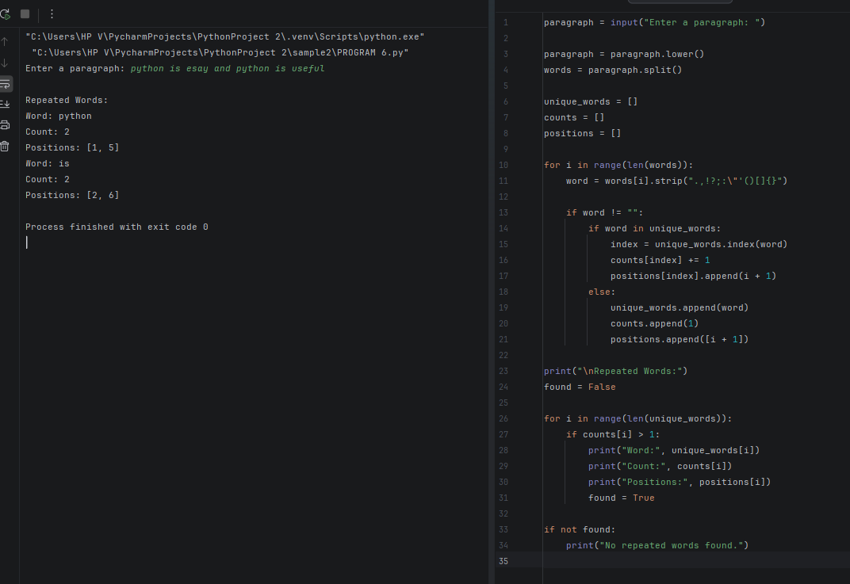

10. Conclusion
Thus, the Python program successfully identifies repeated words in a paragraph by converting the text to lowercase, removing basic punctuation, counting word occurrences, and recording their positions. This case study demonstrates the use of strings, lists, loops, and conditional statements in text analysis.

